ASPRS
Data Preservation and Archiving Committee (DPAC)

13 November 2014

Attendees: Lluis Colomer, Jeff Young, Bill Teng, John Faundeen

Short meeting focused on sharing information regarding the progress made on building the aerial portal (at some point we will need to discuss a good name for the portal). While David Day was not able to attend the meeting he did provide a status of the work he has agreed to undertake. His targets are to have a working version from his location available before Thanksgiving and transfer it to ASPRS by February. Those time lines would work well with our plan to highlight the portal at the ASPRS Annual Conference in Tampa May of 2015.

David also sent some database screen shots to relay the work that has already occurred. They are below:

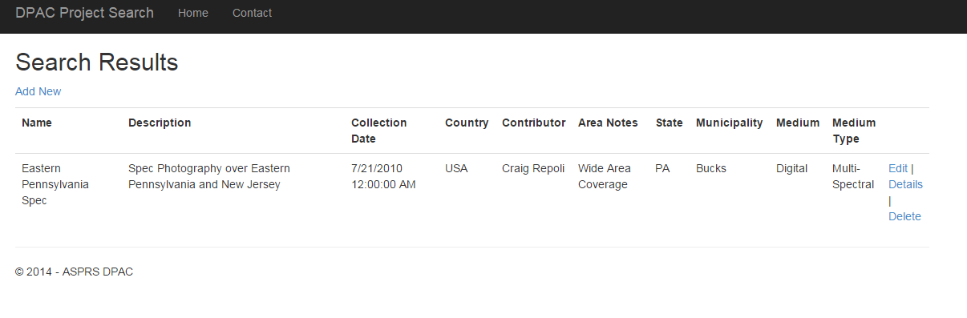
Search results page (Admin view). The Edit and delete options would not be available in regular search results.

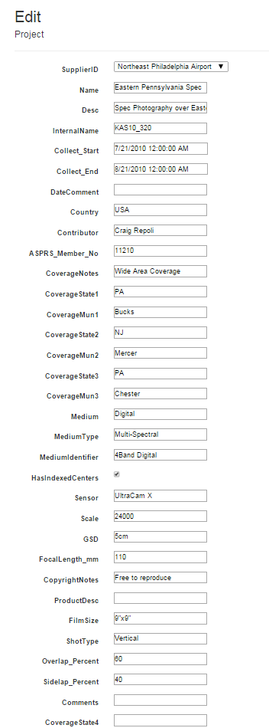

Edit a project/asset detail (Admin only).
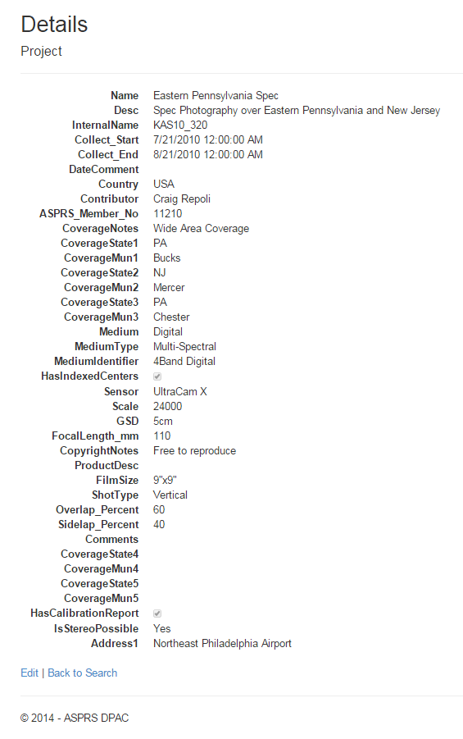
User View.

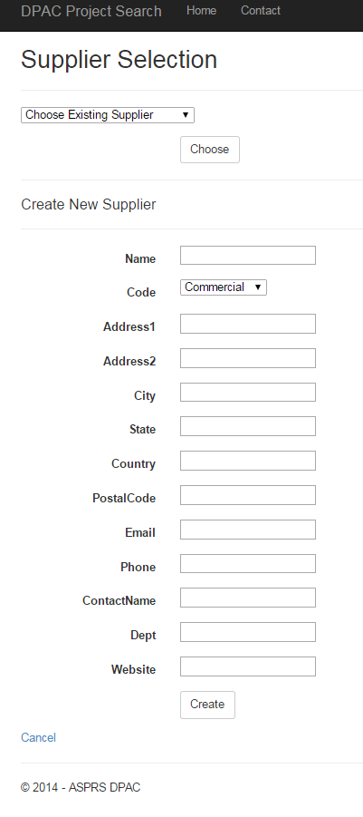
Adding or editing a supplier to the database.

As the screen shots show, our vision is beginning to become a reality! Thanks to David for taking this to the next step and for everyone else for heir inputs to the process and data schema development. Once built, we have potentially hundreds of records to import plus an active solicitation effort to get records from many sources.

Next DPAC Meeting is scheduled for 17 November 2014 at 10:00 MT. This will take place during the APSRS PECORA-19 Symposium. We’ll meet in the Platte River room on the Ballroom level.

