Introduction
I took an existing project that has 5000 ft by 5000 ft tiles and a NPS of 1 meter. The following screenshots show various criteria to look at the new proposed specifications to define Low Confidence areas. All screen shots only show the results of analyzing the ground classification.

In all cases the blue outlines are water boundaries, and the gray shading represents where no ground LiDAR points were contained in the various grid cells. The purple outline represents where a visual interpretation indicated further investigation of a low confidence area. This is a stand of dense hemlock trees and prior to the LiDAR flight a ground observation confirmed that the LiDAR pulses would have a difficult time penetrating the canopy. The black polygon represents a low confidence area that the contractor produced.

There are two screen shots for each grid cell size: one for the entire tile and the second for a zoomed in area around the low confidence area.

1 METER CELL SIZE
In Figures 1 and 2, the red pixels represent where the point density is 1 point per 1 meter grid cell. In this case the gray areas would be representative of Low Confidence areas. While I am not an expert in GIS, it appears that it would be difficult to aggregate these pixels because of the speckled nature of the data.

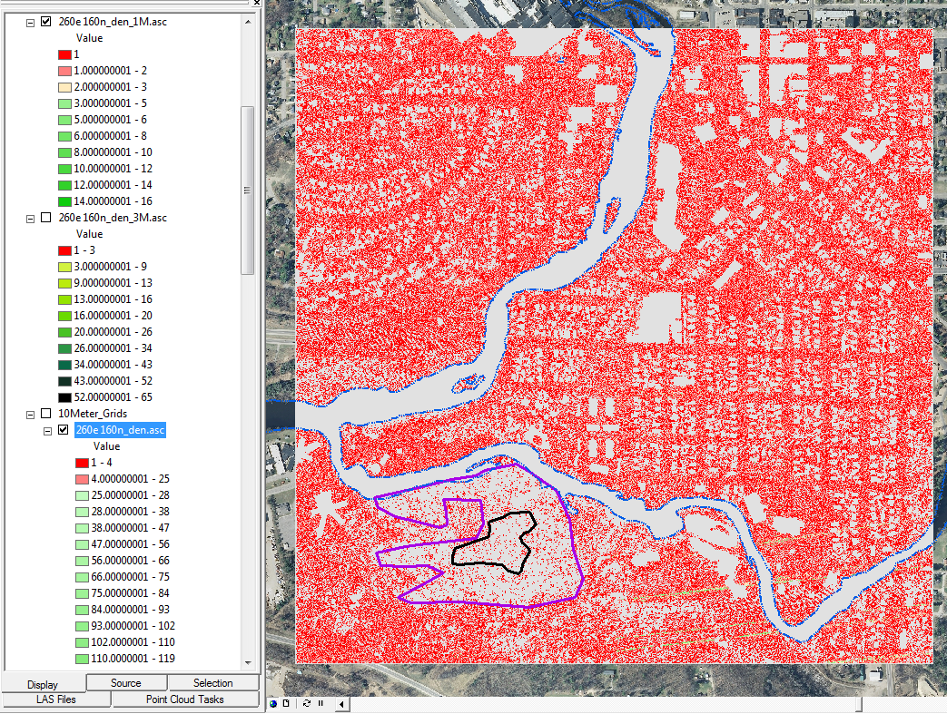
Figure 1 - 1 Meter Grid Cell Size

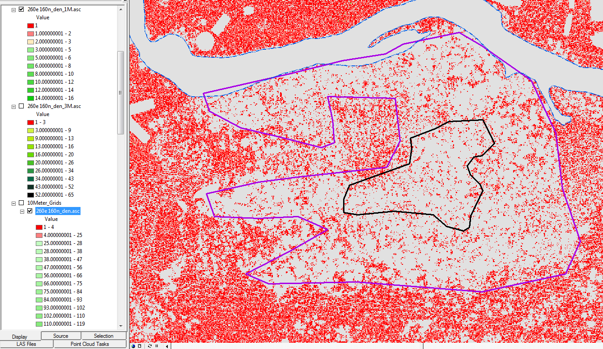
Figure 2 - 1 Meter Grid Cell Size

3 METER CELL SIZE
In Figures 3 and 4, the red pixels represent grid cells that have less than 3 points per 3 meter grid cell. These figures represent the approximate recommendations by ASPRS. The identification of Low Confidence areas now appears to be more obvious and the aggregation of pixels with 0 to 2.5 (rounded to 3) points per pixel should be able to be automated.

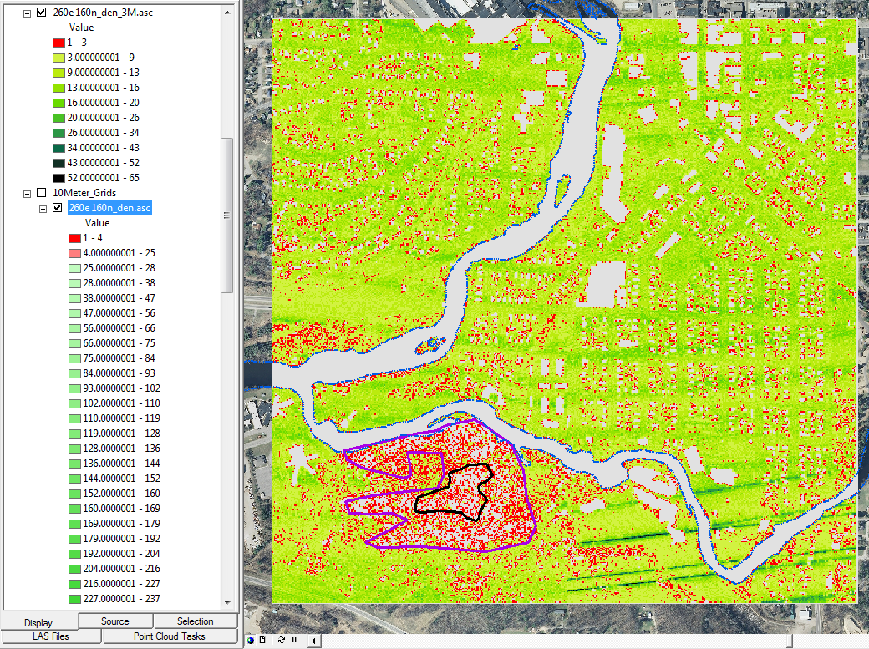
Figure 3 - 3 Meter Grid Cell Size

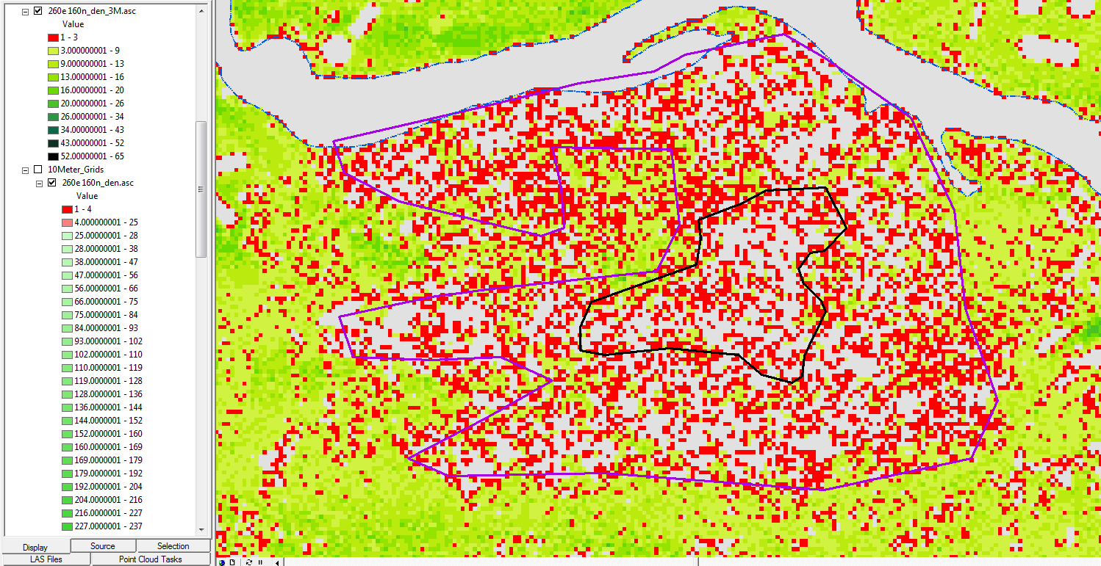
Figure 4 - 3 Meter Grid Cell Size

10 METER CELL SIZE
In Figures 5 and 6, the red pixels represent grid cells with 1 to 4 points per pixel and the rose color represents those grid cells with 4 to 25 points per pixel. These results show a close agreement with the ASPRS recommended solution.

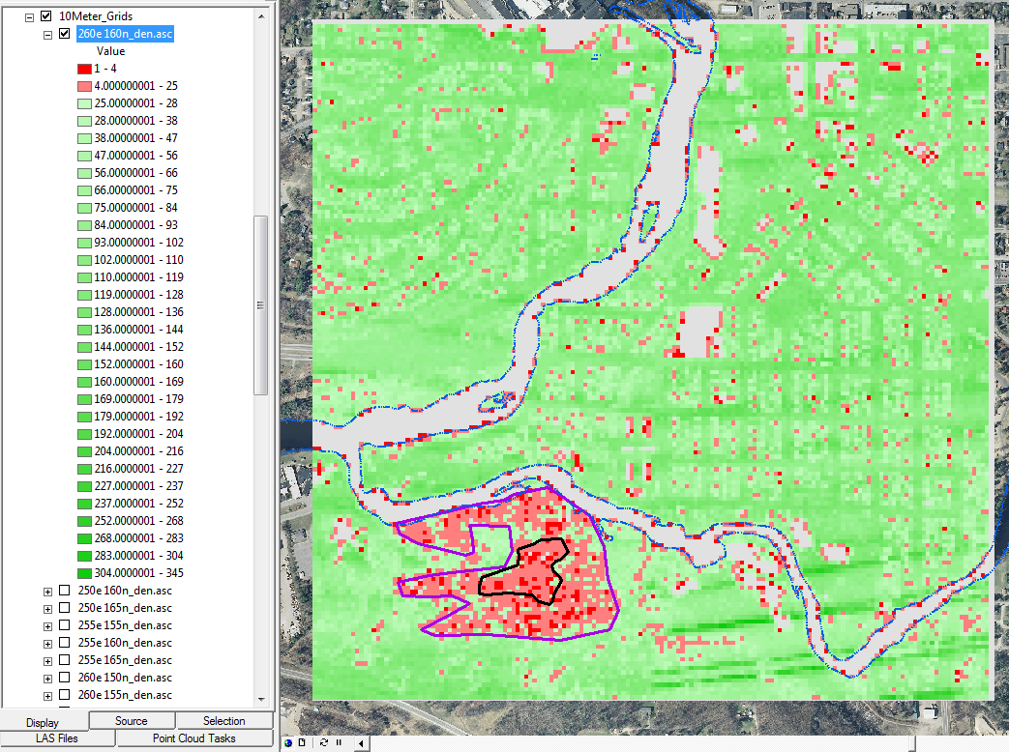
Figure 5 - 10 Meter Grid Cell Size

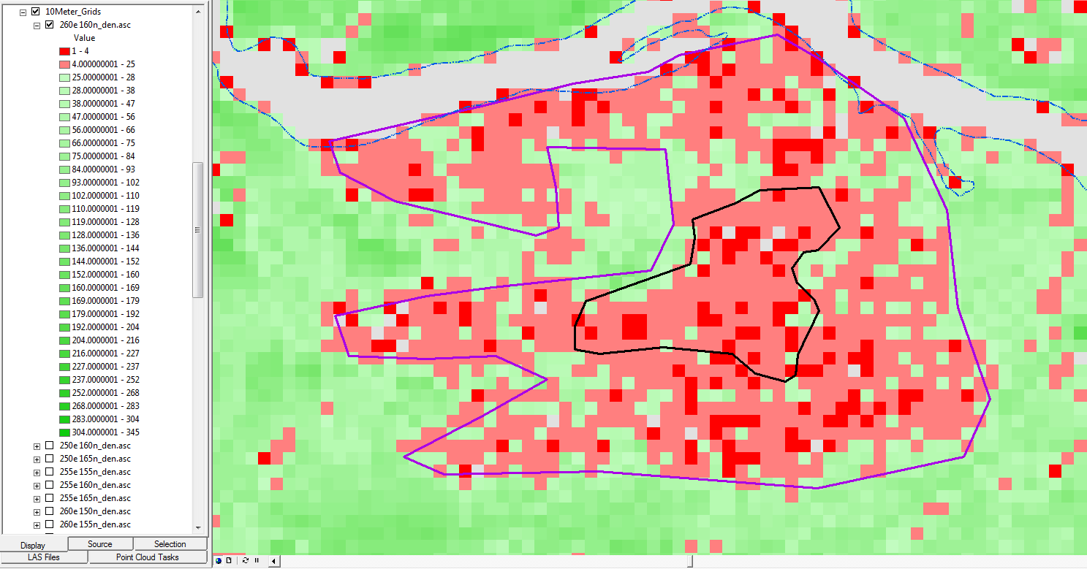
Figure 6 - 10 Meter Grid Cell Size

CONCLUSIONS
- The ASPRS proposed recommendations for the parameters to be used to determine Low Confidence area appears to work quite well.
- Picking a cell size that is smaller than the recommendations provides more detail but creates more speckling that would make automated generalization more difficult.
- Picking a cell size that is larger the recommended size provides remarkably similar results. It also appears that aggregation of the cells would be easier.
- The proposed recommendations by ASPRS are more definitive than the previous Draft specifications and provide a more definitive method to determine Low Confidence areas.

