ASPRS
Data Preservation and Archiving Committee (DPAC)

12 June 2014

Attendees: Michael Hauck, Lluis Colomer, Bob Pope, Bill Teng, Jeff Young, David Day,
John Faundeen

A presentation by Jon Polay from Voyager was provided to DPAC. Michael Hauck made the connection to Voyager as the system aligns to the DPAC goal of providing a portal representing aerial photography holdings from ASPRS members and non-members. It is the belief of the DPAC that much of these holdings are basically unknown to the remote sensing world and could benefit from the exposure such a portal could provide.

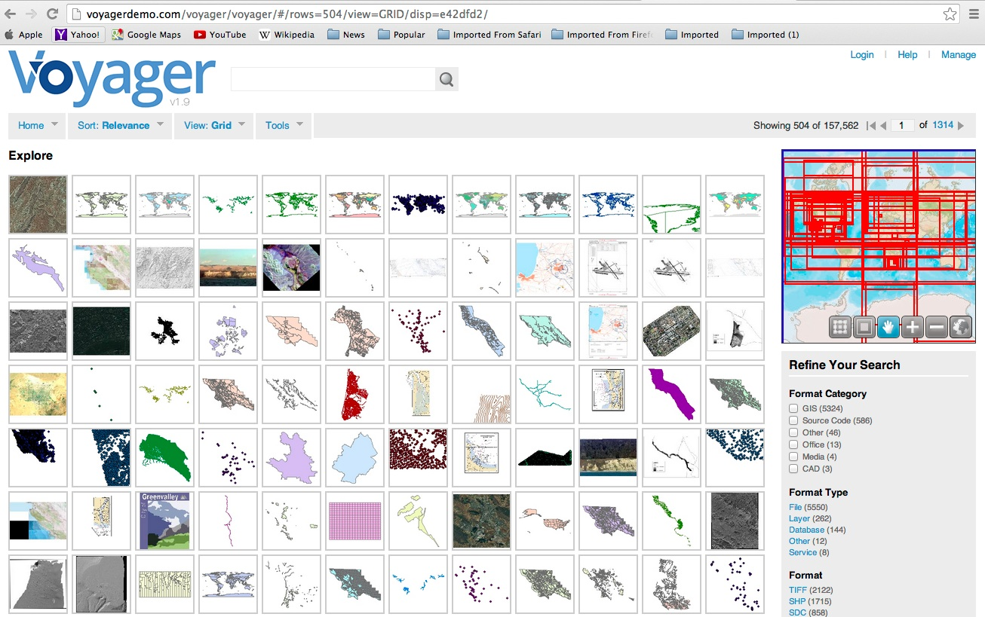

Jon Polay provided an excellent overview of the system. Some of the key points captured include:

- Handles over 1,700 file formats including non-spatial
- Harvests other systems metadata – no actual data transfers involved
- All browsers supported
- Creates a local metadata catalog
- Can geo-tag non-spatial data using a gazetteer
- NGA is one of their larger customers
- Can handle spreadsheet data, which at least initially, a lot of ASPRS member information may arrive as
- The look-and-feel can be modified as well as a “branding” element
- Can pre-set a geographic map to a specific extent that makes sense for a collection
- Can do federated searches by connecting to source provider servers
- Could be set up to have an internal, ASPRS view as well as a Public view
- Can plug into ArcMap to use Arc tools
- Creates FGDC and/or ISO metadata on the fly

David Day then provided a brief overview of what he had done previously for the ASPRS History Committee. A simple SQL database and website were established allowing key-word/text-based searching. His vision for the ASPRS DPAC aerial portal was to build a simple SQL database having similar search features to the History Committee page. Bob Pope relayed that the multiple sources his is compiling will have minimal metadata available. At best, we will get provider contact information along with US state and the county overflown. Anything beyond that will be appreciated, but some providers did not build or maintain exhaustive metadata.

Action: Bob Pope to send out to the DPAC and Jon Polay his file of approximately 300 sources as a first population effort.

In summary, DPAC had a great discussion on some possible next steps to stand up this aerial portal. Much discussion on this exciting topic will continue between and during DPAC sessions.

Next DPAC Meeting is scheduled for 10 July 2014.

