6th UF/FL-ASPRS Joint LiDAR Workshop
16 November 2018

Presented by:
Florida Region – ASPRS
University of Florida – Geomatics

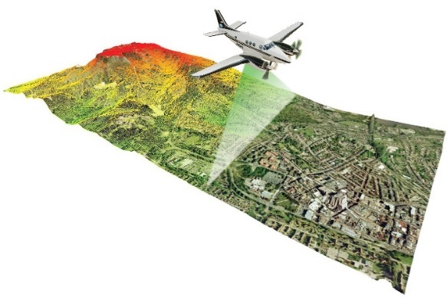

and our
Sponsors:

GOLD SPONSORS SILVER SPONSORS

PROGRAM

AM SESSION 1: Welcome and Agency Updates

08:30- Arrivals and Sign-in
08:45- Welcome & ASPRS Business – Al Karlin
09:00- Peninsula LiDAR Program – Dewberry:
(Keith Patterson/Elisa MacPherson)
09:20- Coastal Mapping Program – USGS: Cheryl Hapke
09:40- State Plane Revision – Rick Pryce (FSMS)
10:00- UAV Briefing – USACE/SAJ – (Victor Wilhelm)

10:30 - COFFEE BREAK – 11:00

AM SESSION 2: Research Presentations

11:00 – Full Motion Video in QGIS – Eric Andelin (Wantman Group)
11:20 – Terrestrial and UAV LiDAR – Lori Collins (University of South Florida)
11:40 – USVI SfM Bathymetry – C. Wayne Wright (USGS/NASA)
12:00 – UAS-based Shoreline Monitoring – Sudhagar Nagarajan (Florida Atlantic University)

12:20 – Lunch Break – 13:20

PM SESSION 3: UF/Geomatics Workshop

13:20 – UAV LiDAR Applications in Tropical Ecosystems – Eben North Broadbent

13:40 – Applications of Uncertainty (TPU) – Ben Wilkinson

14:00 – UAS Applications to Improve Interdisciplinary Research – Adam Benjamin

14:20 - COFFEE BREAK – 14:40

PM SESSION 4: Technical Workshop

14:40 – Drone LiDAR Accuracy Considerations – GeoCue (Lewis Graham)
15:00 – UAS Autocorrelated Pointcloud Accuracy – Woolpert, Inc. (Mike Zoltek)
15:20 – Commercial UAS Project Cases – Surdex Corp. (Ed Turner)
15:40 – New UAS LiDAR Sensors – ReiglUSA (My-Linh Truong)
16:00 – UAS Applications – GPI GeoSpatial (Matt LaLuzerne)
16:20 – Geiger-Avalanche Mode Lidar Analysis – Harris Corp. (Kristian Damkjer)

PM SESSION 5 – Wrap-up and Planning

16:40 – See you in the Spring (June ‘19) … Adjourn

To join the
American Society for Photogrammetry and Remote Sensing,
please visit:

https://www.ASPRS.org

and use the
“JOIN ASPRS NOW” button

UF/IFAS/Mid-Florida Research & Education Center
2725 South Binion Road
Apopka, FL 32703

